Relay Switch
CP028
Image:
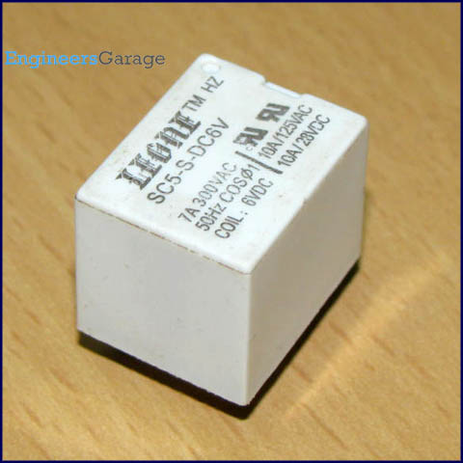
Relay is an electromagnetic device which is used to isolate two circuits electrically and connect them magnetically. They are very useful devices and allow one circuit to switch another one while they are completely separate. They are often used to interface an electronic circuit (working at a low voltage) to an electrical circuit which works at very high voltage. For example, a relay can make a 5V DC battery circuit to switch a 230V AC mains circuit. Thus a small sensor circuit can drive, say, a fan or an electric bulb.
A relay switch can be divided into two parts: input and output. The input section has a coil which generates magnetic field when a small voltage from an electronic circuit is applied to it. This voltage is called the operating voltage. Commonly used relays are available in different configuration of operating voltages like 6V, 9V, 12V, 24V etc. The output section consists of contactors which connect or disconnect mechanically. In a basic relay there are three contactors: normally open (NO), normally closed (NC) and common (COM). At no input state, the COM is connected to NC. When the operating voltage is applied the relay coil gets energized and the COM changes contact to NO. Different relay configurations are available like SPST, SPDT, DPDT etc, which have different number of changeover contacts. By using proper combination of contactors, the electrical circuit can be switched on and off. Get inner details about structure of a relay switch.
Pin Diagram:
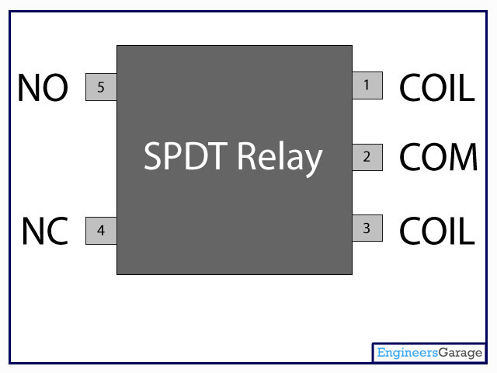

Insight - How Relay Switch works

Table of Contents:
- Insight - How Relay Switch works
- Contact Mechanism
- DC Coil & Spring
Relay is one of the most important electromechanical devices highly used in industrial applications specifically in automation. A relay is used for electronic to electrical interfacing i.e. it is used to switch on or off electrical circuits operating at high AC voltage using a low DC control voltage. A relay generally has two parts, a coil which operates at the rated DC voltage and a mechanically movable switch. The electronic and electrical circuits are electrically isolated but magnetically connected to each other, hence any fault on either side does not affects the other side.

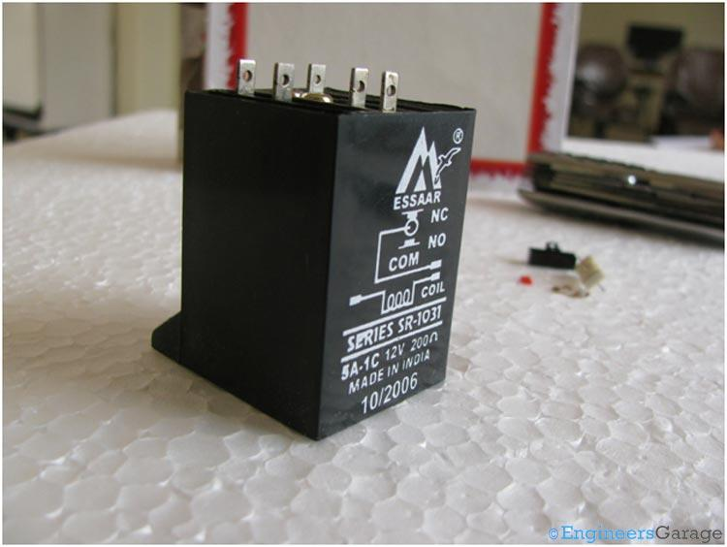
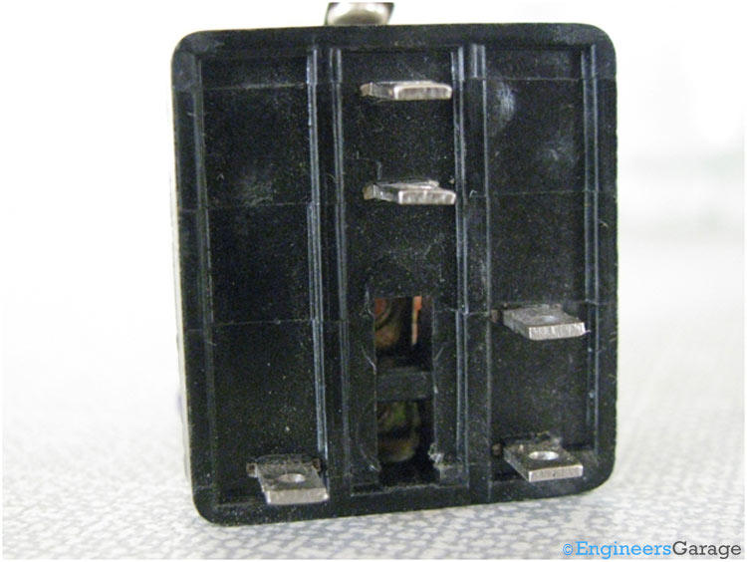

Relay switch shown in the image above consists of five terminals. Two terminals are used to give the input DC voltage also known as the operating voltage of the relay. Relays are available in different operating voltages like 6V, 12V, 24V etc. The rest of the three terminals are used to connect the high voltage AC circuit. The terminals are called Common, Normally Open (NO) and Normally Closed (NC). Relays are available in various types & categories and in order to identify the correct configuration of the output terminals, it is best to see the data sheet or manual. You can also identify the terminals using a multimeter and at times it is printed on the relay itself.
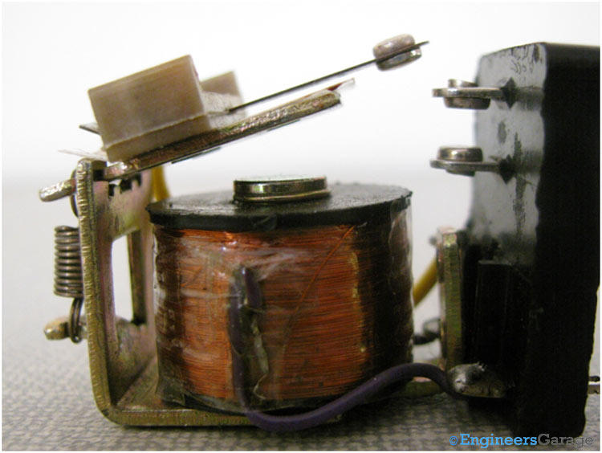
The internal structure of the relay is shown in the image above which is embedded inside the plastic covering.

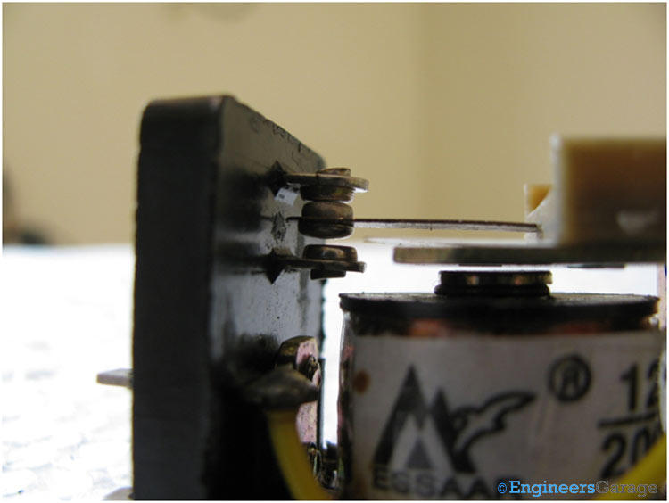

You can see a mechanically movable lever also called the common terminal. By default it remains in touch with one of the fixed terminal which is called the Normally Closed (NC) terminal. The other terminal which is not connected to the common point is called the Normally Open (NO) terminal.
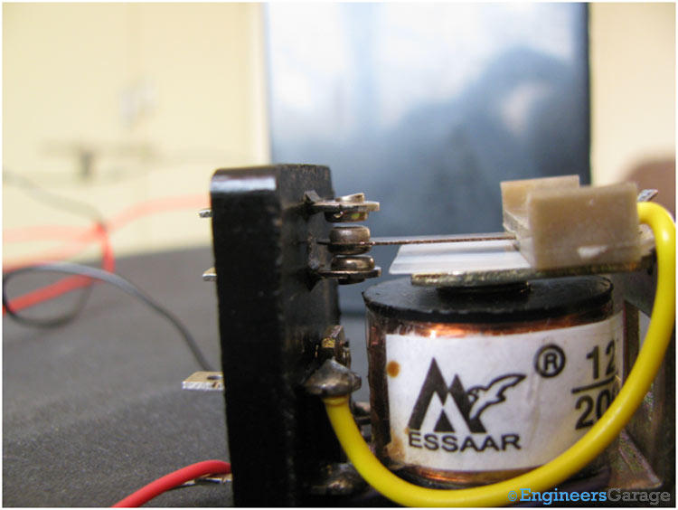
When we give the operating voltage to the relay coil, current starts flowing and it behaves as an electromagnet. The common terminal which is made up of iron gets pulled down by the electromagnetic force and gets connected to the Normally Open (NO) terminal as ahown in the figure above.

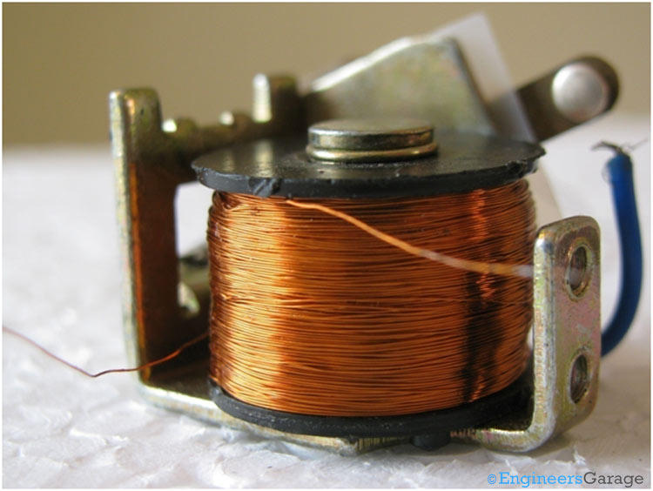
The above image shows the DC coil used to create the necessary electromagnetic force when current is passed through the wires.
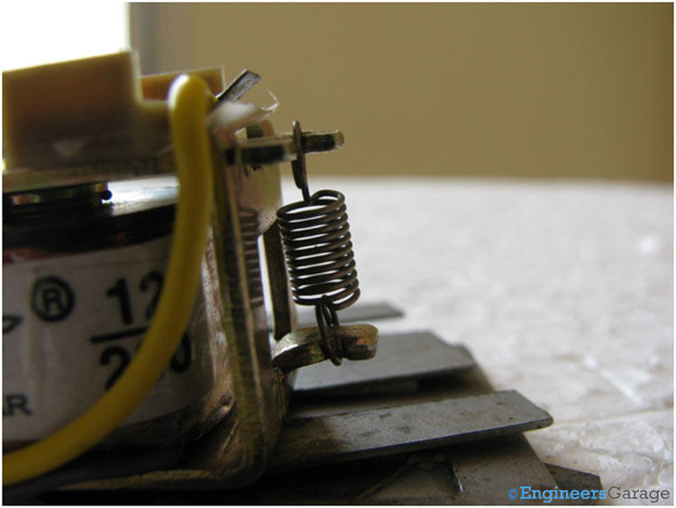
The above image shows the spring that keeps the lever in contact with the NC terminal when there is no current flowing in the coil.

